To test if Neuropresin and Neuropostin are sufficient for synapse formation, I would begin by using a cell-based assays of synapse formation using microfluidic devices to control pre/post-synaptic partners (Millet and Gillette 2012). In this cell-microfludic assay, the left chamber would represent presynaptic manipulations while the right chamber would represent postsynaptic manipulations and readouts. How might this work? I would first begin by plating hippocampal neurons in the left chamber and allow their axons to migrate to the right chamber using netrins (**Fig 1A**, green axons). Once axons have grown, I can plate my manipulated neurons in the right chamber (**Fig 1A**, red cell), e.g. hippocampal neurons that have been transfected with full-length neuropostin or truncated variants (**Fig 1B** for list of candidates). The screen of these constructs will tell me if these combinations can form functional synapses. The readout for this experiment will be synapse density (costain with Synaptophysin and PSD-95), EM (for asymmetric synapse morphology), and patch single cells and test for mEPSCs (right chamber allows for easy identification of postsynaptic targets).

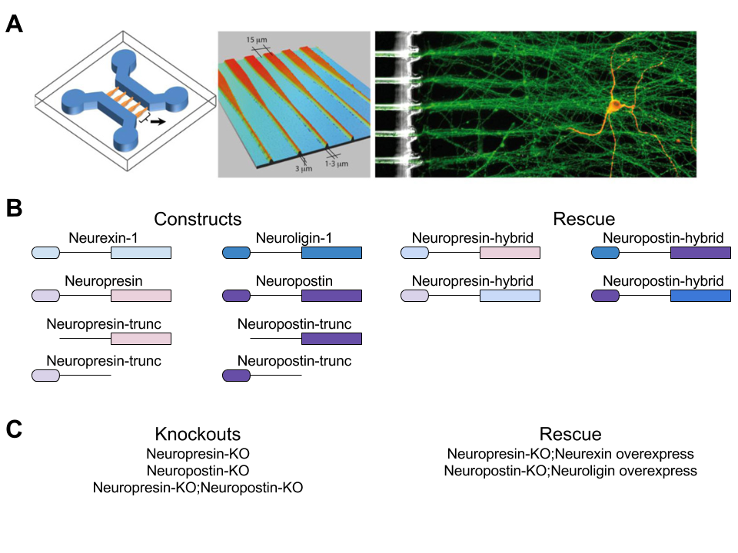

Figure 1 – Design of Experiments

To test if Neuropresin and Neuropostin are necessary for synapse formation, I would begin by using genetic studies of single (Neuropresin and Neuropostin alone, **Fig 1C**) and combined knockout (KO) mice (Neuropresin and Neuropostin double-KO, **Fig 1C**). If the resultant mice are viable, I will test for phenotypes in these ways:

1. Mini-EPSCs in CA1 hippocampal neurons in slice
2. Release probability
3. Evoked postsynaptic currents
4. AMPA/NMDA ratio
5. Short-term synaptic plasticity (paired-pulse)
6. Long-term synaptic plasticity
7. Long-term synaptic depression
8. Morris Water Maze

Phenotypes in any of these assays, either in the single or double KO-mice will instruct me as to how Neuropresin and Neuropostin are necessary for functional synapse formation/maintenance.

**References**

Millet, L. J. and M. U. Gillette (2012). "New perspectives on neuronal development via microfluidic environments." Trends Neurosci **35**(12): 752-761.